**Postman Variable**

1. Global Variables
2. **Collection variables**
3. **Environment variables**
4. **Local variables**

**🡺Global variables** allow you to access data between collections, requests, test scripts, and environments. Global variables are available throughout a [workspace](https://learning.postman.com/docs/collaborating-in-postman/using-workspaces/creating-workspaces/).

EG : pm.global

**🡺Collection variables** are available throughout the requests in a collection and are independent of environments, so do not change based on the selected environment

**🡺Environment variables** allow you to execute all API Suite in different environments, for example development / testing / production/ UAT Environment. Only one environment can be active at a time.

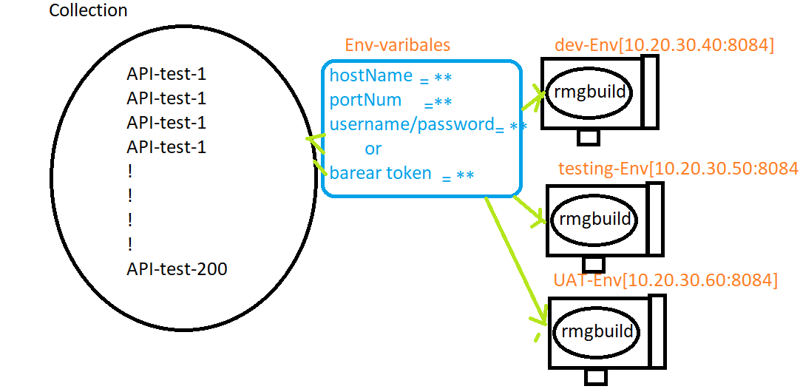

**🡺Local variables** are temporary, and only accessible in your request scripts. Local variable values are scoped to a single request or collection run, and are no longer available when the run is complete.

EG

Let varNAme = “deepak”

Console.log(varNAme)

How to verify/view the logs in Postman / how to debug the API test

IN POSTMAN window🡺 view 🡺 Show Postman log

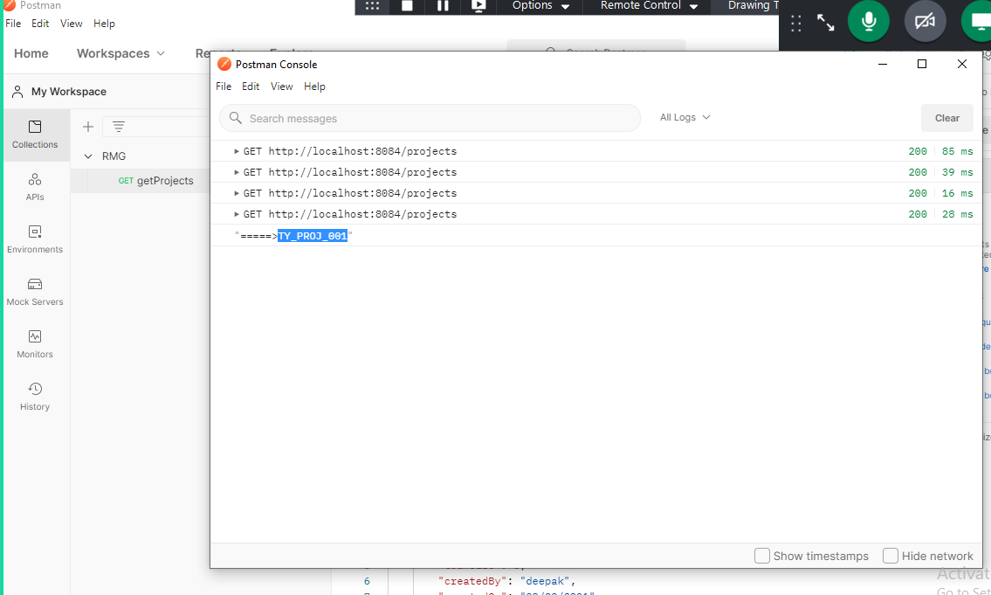

How to capture the data from Response ?

Use “JSON value check snippets” & than modify the code as per the requirement

